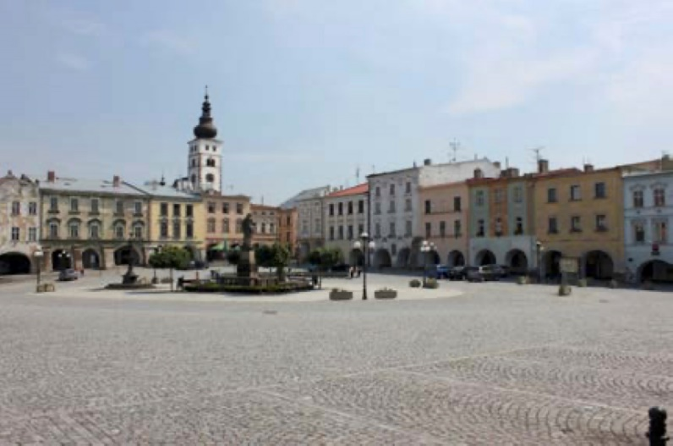

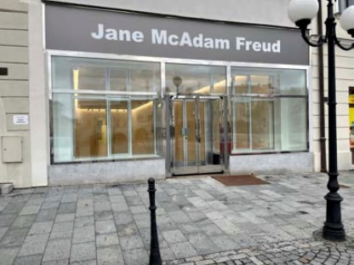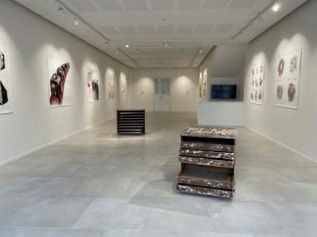
Příbor
Sigmund Freud Square and the Jane McAdam Freud Gallery

Delegates should find their own accommodation.
There are many small hotels/guest-houses in Příbor and also some Air B&B facilities such as the Lucerna and the Lexor.
The best way to find accommodation is through sites such as:
Booking.com
Tripadvisor.co.uk
Airbnb.co.uk

There is also accommodation available in nearby towns such as Koprivnice, Hukvaldy and Novy Jicin.
A further source of information is the Příbor Tourist Office where they speak English and can advise on
other accommodation which may not be advertised on the main sites.
https://www.pribor.cz/cz/turisticke-informacni- centrum-tourist-information-centre/

TRANSPORT From the UK:
To Ostrava
By far the easiest way is by plane from London Stansted to Ostrava, by Ryanair.
Příbor is 5 minute taxi ride from airport. Hire cars are available from the airport.

To Brno
Flights daily. 2 hours from Příbor by taxi. Train or coach is available from centre of Brno.

To Prague
Flights daily. Train is best way. 3-4 hours to Ostrava. Then local train to Studenka and change to Příbor.

Other possible routes are via Krakow and Katowice,

From Europe
If travelling by train, head to Ostrava, then catch train to Studenka and change trains to Příbor.

